



LibreBus is a project that will integrate a tour among several countries from Central American region and it will complemented with participatory spaces over Internet.
About twenty persons with different nationalities and different skills will come together over a common subject: Free Culture and the promotion of knowledge as a collective asset. LibreBus is an invitation to dialogue and to meet, to the creation or regional networking for empowering a shared culture of Central America.



LibreBus is a dialogue and a meeting focused on:


Conocimiento
Libre y
Biodiversidad
Software  Libre | Knowledge and Culture has been constructed historically in participative ways. The traditional knowledge, biodiversity and cultural food, the popular culture, the artistic expressions, the scientific and academic knowledge, all are transmitted and enriched thanks to the exchange of perspectives and experiences. We believe in knowledge as a common that need to be diverse and shared to keep alive and in constant transformation.
 | When we talk about free software, we refer to computer programs that allow us freedom of choose, share, enhance, study an use with any purpose. The world's free software movement develops and promotes software freedom, a freedom that protect many other freedoms. In a world that relays on technology, in order to have the ability to express ourselves, organize ourselves and construct knowledge, we need to take control of the software that we use.
Libertad  de  Expresión | New technologies allow us to use the power of the press and publish in real time. We use our freedom of speech through blogs, social network services, doing presence activism, organizing ourselves as collectives that surpass geographical boundaries to reflex and provide meaning to the reality from our own voices. But this freedom and net neutrality are not assured. That's why it is urgent to define strategies and propose alternatives that warrant the democracy of public information spaces.
Libertad  para  Compartir | We believe that sharing is good: strength creativity, social networks, research, education and the cultural wealth of humanity. People who create art and knowledge deserves fair recognition and retribution for their work, but also to share their creations. That's why it is important to lower the technical, legal and social barriers that limit this right. On the Free Culture movement we promote the freedom to share, remix and transform.

Before the travel starts, there will be promotion activities on Internet, using social network services, and other communication channels as well, to invite people to include our activities in their schedule and to participate.

During the tour there will be press conferences, we will be online all the time, feeding the official web site and interacting using social networks, personal blogs and mobile phones. All the tour will be documented with photos, video and audio. We will collect material to be included in the first cultural repository of Central America. En each city we will hold a series of activities inviting key people to participate and collaborate.



After the tour there will be a regional seminar where will be explored the findings and will dig deeper on the transversal topics.

There is hope that this tour and the activities will serve as catalyst for other initiatives and to generate regional support network on the transversal topics of this project.



LibreBus will sustain diverse activities in San Jose and Liberia in Costa Rica, Managua and Granada in Nicaragua, Tegucigalpa in Honduras, San Salvador in El Salvador; and La Antigua and Guatemala city en Guatemala. There are still activities to define, so we still have room for suggestions and proposals:

 | Tue3 | Wed 4 | Thu 5 | Fri 6 | Sat 7 | Sun 8
Country | Costa Rica  San José | Costa Rica  San José | Costa Rica  Liberia | Costa Rica | Nicaragua  Managua | Nicaragua  Granada
 |  |  |  | Nicaragua | Nicaragua  Managua | Nicaragua  Granada
Morning |  | Press Conference  Forum about Open Access | Transit to Liberia | Workshop | Workshop | Transit to Granada  Workshop
Afternoon | Forum Legal Context and possibilities for sharing | Round Table Transversal Topics  Cultural Party | Workshop  Peña Cultural | Transit to Nicaragua | Press Conference  Cine Forum | Conference  Cultural Party
Mon 9 | Tue 10 | Wed 11 | Thu 12 | Fri 13 | Sat 14 | Sun 15
Nicaragua | Honduras  Tegucigalpa | El Salvador  San Salvador | El Salvador  San Salvador and Santa Tecla | El Salvador | Guatemala  City | Guatemala  Atitlán
Honduras | Honduras  Tegucigalpa | El Salvador  San Salvador | El Salvador  San Salvador and Santa Tecla | Guatemala | Guatemala  City | Guatemala  Atitlán
Transit to Honduras | Workshop | Transit to  El Salvador | Knowledge and Software | Transit to Guatemala | Press Conference | Cultural  Activities in Atitlán
Work Session on the road | Cultural  Party | Software Libre  Convivial | Art and Biodiversity | Activities in Campus Tec | Hackaton of Public Data  Travel to Atitlán | Comunal activities  Closing Party in Atitlán
Mon 16
Guatemala | Return Trip | Return Trip
Return


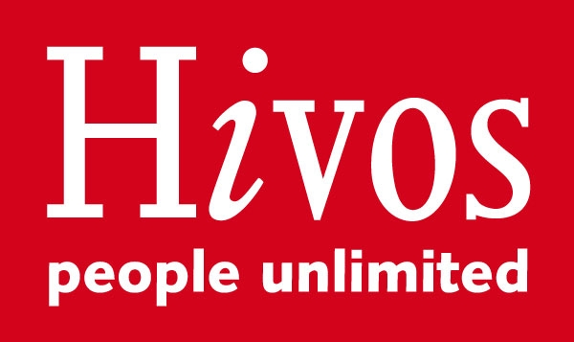

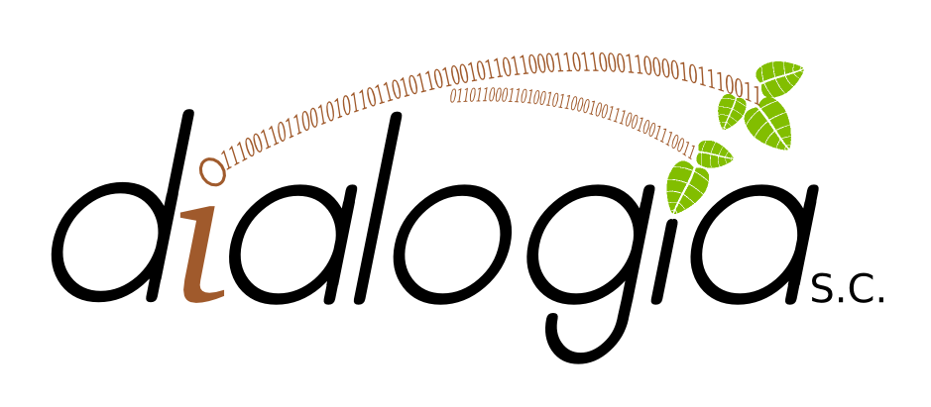
The project is administrated by Dialogía de Información y Comunicación, a non govermental organization based in Costa Rica. Its main objectives include: promote meaningful and empowering use of information and communication technologies; maximize technology use for social change and strength of the social and community networks; promote development, grow and appropriation of free software and free culture; enhance the collective and free construction of knowledge, from popular focus and gender inclusion; and create spaces for diffusion, visualization and sharing of knowledge (http://dialogia.org)

The coordination team are:

Carolina Flores Hine. Psychologist, her work has been focus on Social Communication, Information and Communication Technologies, Methodology and Implementation of processes for strategic use of Internet and change toward Free Software in the Central American Region. She also wrote in her blog Tics Nerviosos.

Renata Ávila is leader of the chapter Creative Commons Guatemala, she is lawyer and obtained a Master in Intellectual Property at University of Turin. She is writer for Global Voices and collaborates with the research in Latin America for the initiative OpenNet. At this time she co-direct the second phase of the project "Red de Tecnología para la Transparencia" (Technology Net for Transparency) and supports different initiatives for privacy on the Internet, ICT and freedom of speech on the Internet.

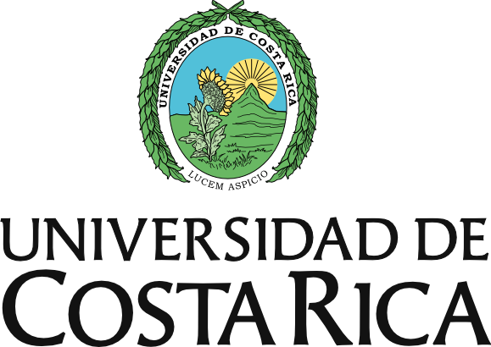
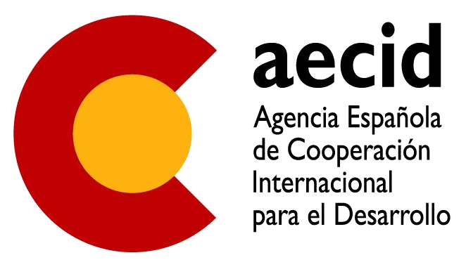
With the support of Erika Valverde. Social psychologist, ecofemenist and activist of free software, she has supported several virtual learning communities, designed and constructed web portals and developed methodologies and processes of participative formation and evaluation for the appropriation of technology of organizations, networks and movements from Central America.

The committee of organizational support has been integrated by Teresa Sempere, publicist and graphical designer with social profile and aid for development; Michelle Thorne, from Mozilla Foundation; and Eva Carazo, activist on topic of biodiversity, collective knowledge and social oganization.

The team of creative coordination has been integrated by the coordination team, the committee of organizational support and by:

- Costa Rica: Jaime Gutiérrez (Computer Engineer (ITCR) and student of the postgraduate program in Cognitive Sciences (UCR). Activist of Free Software and Free Culture) and William Eduarte (Audiovisual Producer, writer and some derivative work. Master en Digital Cinematography New Formats and Audiovisual Media. He has published two books of poetry and a personal blog La Gangrena).

- Nicaragua: Rodrigo Peñalba (Writer, Web Editor, Visual Artist, Blog writer in http://www.penalba.info, and Cutural Producer) and Neville A. Cross (Business Manager, Radio Amateur, Fedora Project Collaborator).

- Honduras: Karla Lara (singer and composer).

- El Salvador: Alex Córdova (Coordinator of Cultural Association for the Scenic Arts, organization from El Salvador that looks to incentive project and iniciatives with aims to the professionalization, production and diffusion of scenic arts http://asociacionescenica.org).

In Costa Rica and Guatemala, Carolina Flores, Eva Carazo and Renata Ávila organize local activities.


LibreBus is possible thanks to the alliance that has been growing since the beginning. Some organizations have collaborated with funding, other providing physical spaces for the activities, institutional support or local contact. This list will be growing and so far is composed by:

HIVOS: Instituto Humanista de Cooperación al Desarrollo

Hivos is a non government organization from Netherlands, that acts with humanistic values. Hivos aims to contribute to world free, just and sustainable, where the citizens – women and men – have equal access to resources, opportunities, markets, and where they can participate in the same way in the processes for decision making that are relevant for their lives, their society and their future. The main activity of Hivos is to facilitate financial and political support to organizations and particular local activities. Hivos network reach 30 countries and more than 750 counterpart organizations. More info at: http://www.hivos.nl/

Creative Commons


Creative Commons is an international non profit organization based in San Francisco, California, that develops support, promote a legal and technological structure to maximize the creativity, innovation and the freedom to share within a digital envirorment. The infraestructure that facilitates consist in a set of author rights and digital tools that set a balance for creators and users within a squeme of "all right reserved" that author rights stablishes. The organizationś vision is to maximize the internet potential for enabling universal access to research and education, full participation in the cultureand to chart a path to a new era of development, grow and productivity. More info at: Creative Commons

Universidad de Costa Rica

"The purpose of the Universidad de Costa Rica is to obtain the transformation that the society needs for reaching the common wealth, with a policy aimed to attain a true social justice, integral development, full freedom and total independence of our people” (Article 3, Organizational Statutes).

One of the objectives of Universidad de Costa Rica (UCR) is to promote open access to the information. This means to promote free access to the complete works. The possibility to ensure the open access is one of the reasons why UCR became an affiliate institution to Creative Commons International in the process of porting the Licenses CC (adapting them to the national laws). More info at: http://www.ucr.ac.cr

Centros Culturales de España (CCE) en El Salvador, Guatemala y Nicaragua

- Centro Cultural de España en El Salvador
- Centro Cultural de España en Managua
- Centro Cultural de España en Guatemala
- Centro Cultural de España en Tegucigalpa

The network of Spanish Cultural Centers is conformed by 23 Cultural Centers that are spread on Latin America, Caribbean and Ecuatorial Guinea. Those are units of the Spanish cooperation and form part of the AECID structure in the foreign together with the Offices for Technical Cooperation (OTC) and the Centers for Formation of the Spanish Cooperation (CFCE). CCE promotes cooperation in the cultural scope, same values and objectives set by the main organizations of international cooperation like UNPD (United Nation Program for Development), UNESCO (United Nation Educational Scientific and Cultural Organization) and so it is reflected in its Spanish Cooperation Direction Plan (2009 - 2012) and its strategy for “Culture and Development”. More info at: aecid.es

Other supports:

The project has received the help of Abax Asesores http://abaxasesores.com a Costa Rican Business that has donated the configuration of the web site http://librebus.org based on Drupal.

Teresa Sempere and Juan Carlos Flores (http://trasmuto.com) have been working on the graphical desing of the project with the colaboration of the creative coordination team.

Creative Commons and Article 19 have collaborated with some funding.

Fundación Rigoberta Menchú, from Guatemala, is supporting with the coordination of activities in Atitlán.

Hotel Mansión Teodolinda in Managua, Nicaragua will host for free, all the passengers of LibreBus

EcoBook project, from UICN organization, will fund a cultural activity in San José, Costa Rica.

¿Do you want to collaborate and be part of LibreBus?

LibreBus still needs to collect some funding. If you can donate, we can offer:

- To include your logo and the information of your organization in our web site www.librebus.org, in the printed materials to be distributed and in the decoration of the bus that will be traveling around five countries con Central America.

- Provide a copy and share the results of our findings.

- A complete list of contacts as result of the map of digital actors of the region.

- The opportunity of being our accomplisher in this attempt of Central American integration and constructing a real integration for the young people of the region.

¿What do we need?

- Financial Support, so far we have reach only 80% of our budget. You can help with:

- Cash contributions to Dialogía de Información y Comunicación S.C.

- Goods or services collaborations: Printed material, lodging, food, tools...

- Host one of the activities: Workshops, cultural parties, conferences, meetings.

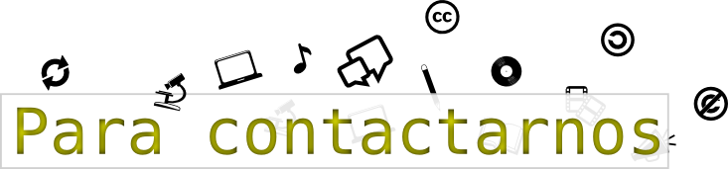

General Coordination:

info@librebus.org

Local contact points:

costarica@librebus.org

nicaragua@librebus.org

honduras@librebus.org

elsalvador@librebus.org

guatemala@librebus.org

